**Pizza Sales Analysis SQL**

**KPI’s Requirement**

1. **Total Revenue**

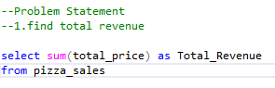

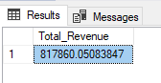

1. **Average Order Value**



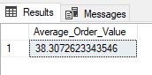

1. **Total Pizza Sold**



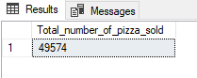

1. **Total Orders Placed**

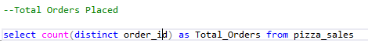

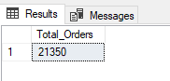

1. **Average Pizzas Per Order**



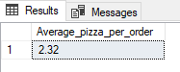

**Charts Requirement**

**1.Daily Trend for Total Orders**

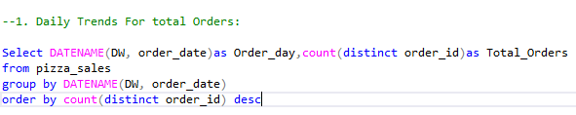

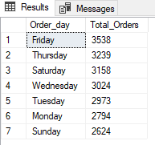

**2.Monthly Trend for Total Orders:**

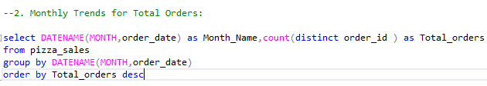

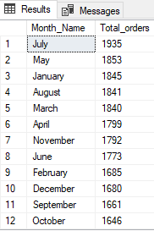

**3.Percentage of Sales by Pizza Category**

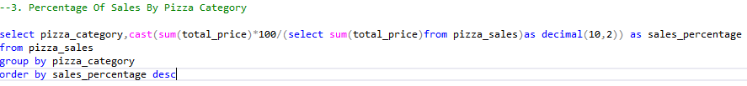

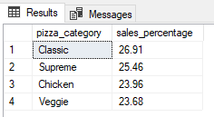

**4.Percentage of sales by pizza size**

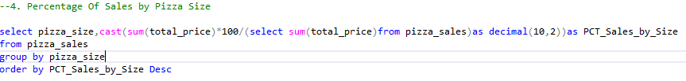

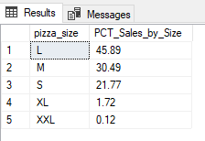

**5.Total Pizza Sold by category**

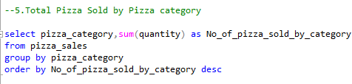

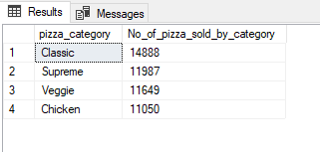

1. **Top 5 Best Seller by revenue. Total Quantity and Total Orders**

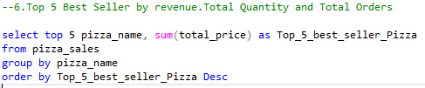

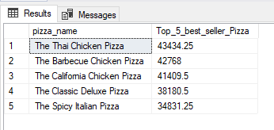

**Top 5 by Quantity**

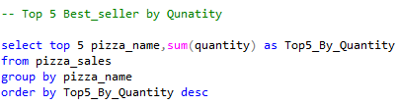

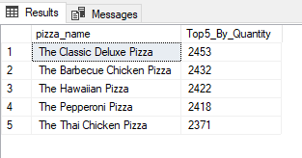

**Top 5 by Total Orders**

